Executive Profile
KEVIN McCABE  Executive Vice President  & Chief Auditor  Wells Fargo & Co  San Francisco, CA | 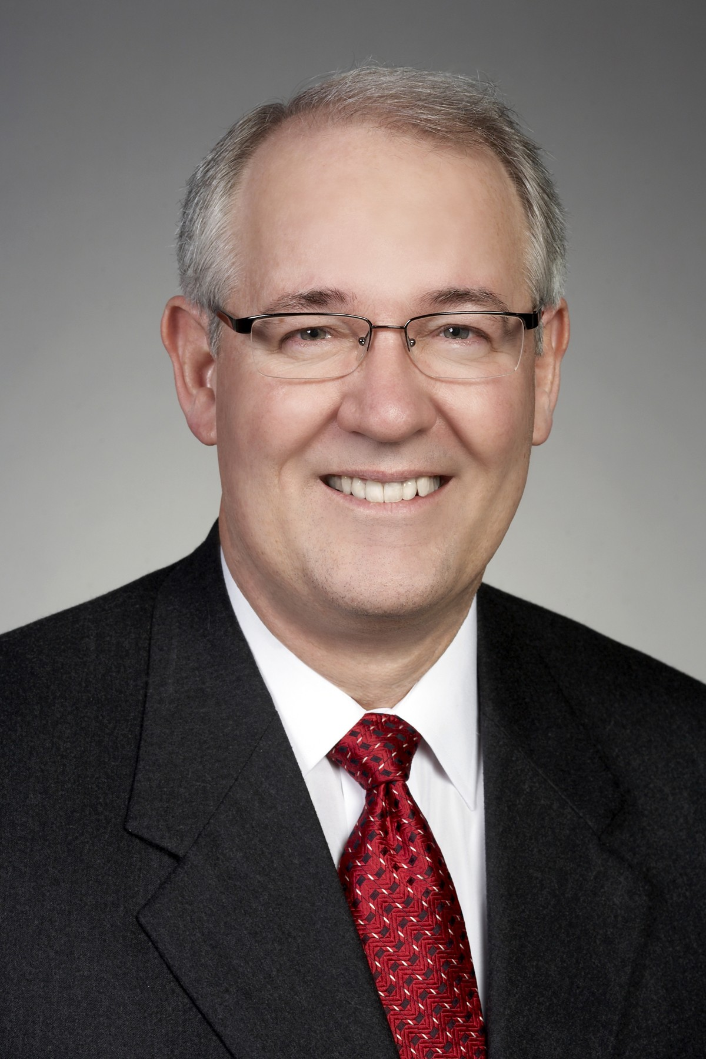

Kevin McCabe became the Chief Audit Executive for Wells Fargo & Co in January 2003 and reports to the Chair of the Audit Committee of the Board and the Chairman & CEO of the company. He is a member of the 12 person Operating Committee; has a staff of approximately 1,000 professionals; responsible for overseeing the company’s audit service and corporate security divisions; and enhancing its governance, risk management and compliance environment.

Kevin has over 35 years of combined public accounting and financial services industry experience. From 1999 to 2002, he was the European Chief Auditor at Citigroup. Prior to that he had various audit roles in New York, Hong Kong and London and he began his career at Coopers & Lybrand.

Kevin serves on the Hong Kong Association of Northern California Board where he is currently Chairman, the San Francisco Opera Board and the Asian Art Museum Foundation Board where he is the Chair of the Audit Committees.

He graduated from Rutgers University where he earned his bachelor’s degrees in economics and accounting. He obtained his Certified Public Accountant, Certified Information System Auditor and NASD Series 3, 7, 24 & 63.

2012

