Janice J. Sackley, CFE
Fiduciary Foresight, LLC

Jan is founder of Fiduciary Foresight, LLC, a fiduciary compliance and fraud examination firm in Kalamazoo, Michigan. Her firm has a dual role in the financial industry: advising client firms and agencies on fiduciary regulations, and managing fraud examinations for small businesses, non-profits, municipalities and quasi-government agencies. Jan is a Certified Fraud Examiner and Professional Investigator.

Jan’s background reveals more than twenty-five years of financial industry experience with banks, insurers, and broker-dealers. Following several years as a Chartered Life Underwriter in insurance sales and time at Merrill Lynch, Jan was engaged by a large regional bank, First of America Bank Corp., to organize the start-up of a new broker-dealer. During her tenure she played a major role in the retail launch of one of the first bank-advised family of mutual funds, The Parkstone Funds, acquired ten years later by another fund group. She also broke ground by leading First of American Brokerage Service to join the Securities Industry Association (now SIFMA) as its first bank-owned member. Under Jan’s watch for more than seven years, the BD she led had no regulatory complaints and no arbitration cases.

This successful track record led to Jan’s engagement in the bank’s trust business as Director of Trust Compliance for First of America Bank and then as Senior Vice President and Fiduciary Risk Manager for National City Bank. At each institution she developed a highly effective team to assess, analyze and mitigate regulatory and fiduciary risks, collaborating with trust, investment management, retirement and other business units to tailor effective compliance and risk mitigation programs. In addition to responsibility for trust policy, she also managed the bank’s compliance with other bank regulatory requirements, including Privacy, Regulation O (insider lending) and Reg. W (affiliate transactions), as well as bank deposit and tying rules. Her duties have required frequent interactions with regulators.

Jan has been a guest speaker at several industry conferences, including the National Society of Compliance Professionals, the Fiduciary and Investment Risk Management Association, the Bank Securities Association, the Bank Administration Institute Risk Conference, and the Asset Management Forum for bank fiduciary examiners. She is a past member of the Michigan Bankers Association Trust Counsel Committee, and a graduate of Leadership Kalamazoo. Jan is an active member of the Fiduciary and Investment Risk Management Association (FIRMA), the Fiduciary Risk Management and Compliance Roundtable, and the Association of Certified Fraud Examiners. She also serves as an editor of the industry publication, Firma Forum, and is a frequent commenter on industry matters, including fiduciary standards.

Contact Info:

Jan@FidFore.com
269-323-8119
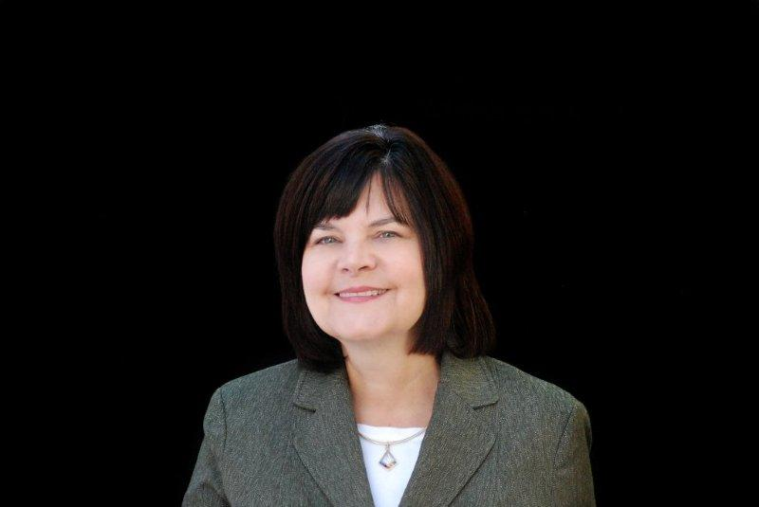
Follow Fiduciary Foresight on Twitter@FidFore

