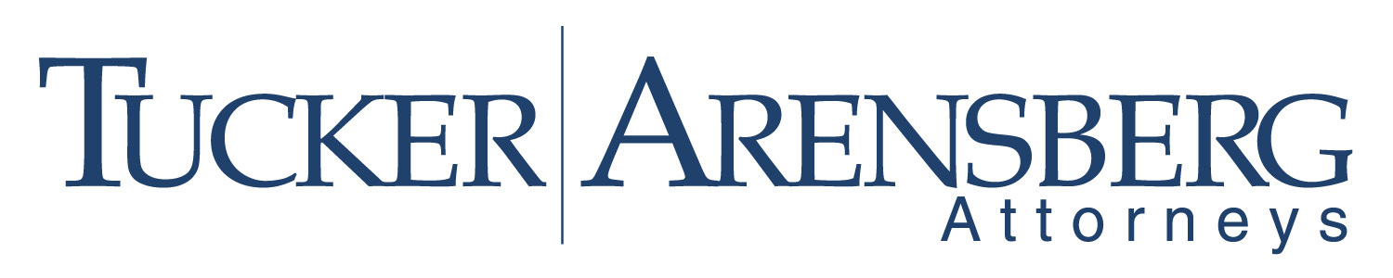
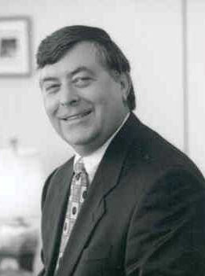
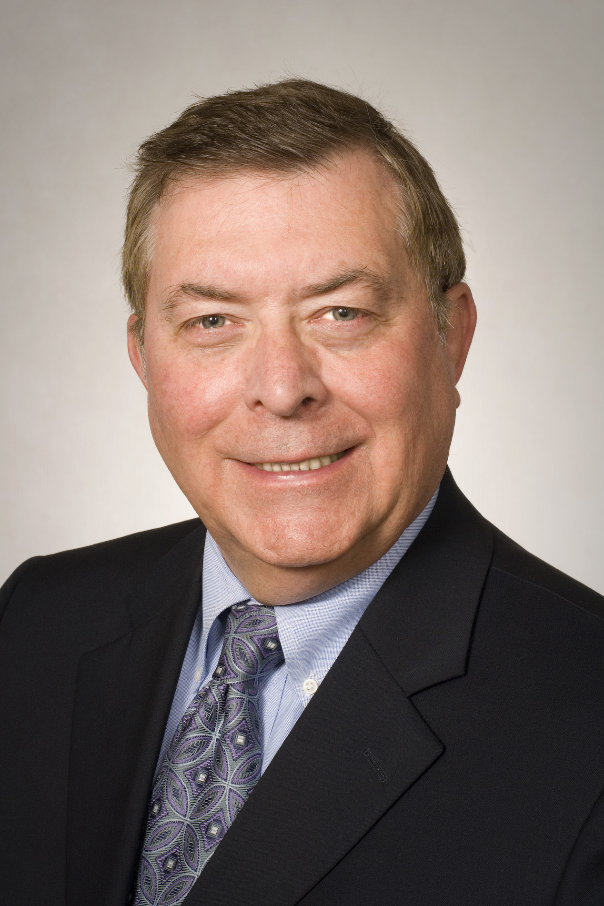
William Campbell Ries
412.594.5646
wries@tuckerlaw.com

William Campbell Ries chairs the Tucker Arensberg Investment Management and Fiduciary Services Practice Group; it provides one-stop shopping for wealth managers and fiduciaries involving complex statutory and regulatory issues, risk management, and compliance. Bill served as Chief Trust Counsel to a major financial institution prior to entering private practice where he acquired a broad range of experience in representing fiduciaries. He serves as an expert witness involving the duties and responsibilities of fiduciaries including estate and trust matters. He provides legal services to financial institutions, including banks, investment advisers, brokers, mutual funds and insurance companies.
Bill is a frequent speaker and lecturer for professional organizations. Bill currently is a member of the Advisory Committee on Decedents' Estate and Trust Law of the Pennsylvania Joint State Government Commission; the group advises the Pennsylvania Legislature on trust and estate matters. He is also a member of the Banking Law Committee of the American Bar Association and previously served as chair of its Fiduciary Services Sub-Committee for over ten years. He is also a member of the Real Property & Probate Section. He served as Chair of the American Bankers Association Trust Counsel Committee and Co-Chair of the National Conference of Lawyers and Corporate Fiduciaries. He was appointed to the Risk Management Advisory Committee of the Bank Administration Institute.
As a recognized expert, Bill was asked to prepare a commentary for the financial services portion of the publication on Trade and Commerce Laws of the Russian Federation. He is the author of The Regulation of Investment Management and Fiduciaries published by West Group. Bill has been named to The Best Lawyers in America® in 2010, 2011, and 2012 in the Trusts and Estates Law category. He is admitted to the United States Supreme Court.
Bill graduated Cum Laude from The Catholic University of America and earned his law degree from Duquesne University School of Law where he is an Adjunct Professor of Law. He has an AV rating in the Martindale-Hubbell Law Directory, which is the highest rating for legal ability and ethical standards awarded by this national directory of lawyers. He chairs the Advisory Committee which investigated the Kilbuck landslide for the Pennsylvania legislature and chaired the committee which recommended legislation dealing with municipalities on developments of regional significance. Bill serves on the Board of Directors for the Pittsburgh Chapter of the American Heart Association. He was a member of the Circles Board and Institutional Development Advisory Committee to The Pittsburgh Cultural Trust. He is also active with Going Home Greyhounds.

