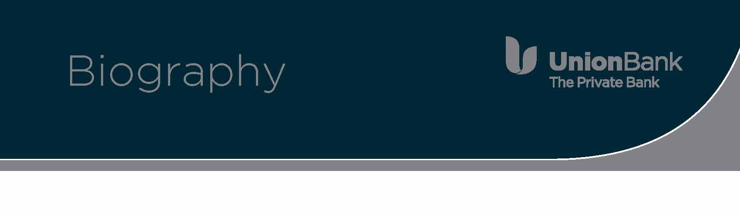

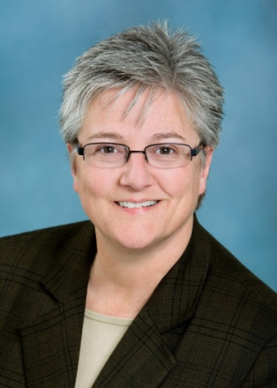**Deborah A. Austin, CTCP**

Senior Vice President

Trust Services Compliance

Union Bank

530 B Street, Suite 925

San Diego, CA 92101

619-230-3526

deborah.austin@unionbank.com

Deborah A. Austin joined Union Bank in November 2008 as the Personal Fiduciary Risk Director, responsible for managing fiduciary risk and compliance for Personal Trust and Institutional Services. Deborah has over 25 years experience in banking, in the areas of audit, compliance and risk management.

Ms. Austin spent the first eight years of her career as an internal auditor for Security Savings in New Jersey responsible for the liability and asset sides of the balance sheet, mortgage servicing and land development subsidiaries. After Security Savings, Ms. Austin spent the next 14 years at the Glenmede Trust Company in Philadelphia in Risk Assurance Services which included internal audit, fiduciary compliance and fiduciary risk management. Her tenure at Glenmede included building and implementing the risk management program, business continuity and responsibilities as Chief Compliance Officer for the Glenmede Funds. Deborah then served as Vice President, Fiduciary Compliance Manager for PNC in the Wealth Management Division where her responsibilities included managing the fiduciary compliance program for personal trust, institutional and benefit services. Deborah also served as the Chief Compliance Officer for the PNC Building Investment Trust and compliance liaison for affiliates and Wealth Management. Deborah was also responsible for fiduciary due diligence and integration for mergers & acquisitions.

Ms. Austin received her B.S. from Neumann College in Accounting and a master’s certificate in Information Systems Auditing from NYU. Deborah is also a graduate of Cannon Trust School, Fiduciary Risk Management program and holds the certificate of Certified Trust Compliance Professional.

Ms. Austin’s professional and community involvement includes past board member and past president of the Fiduciary Investment Risk Management Association. She is currently a member of both the Philadelphia and New York Fiduciary Risk and Compliance Roundtables. Ms. Austin is also a frequent speaker for the Fiduciary Investment Risk Management Association and the Institute of Internal Auditors. Ms. Austin has served on working groups for the American Bankers Association, namely Trade Errors and Fiduciary Key Risk Indicators. She has served as a community volunteer in the capacity of treasurer and fund raiser for the Wenonah Lake Association; as an elected official for the Borough of Wenonah serving as council member and council president, chair of budget & finance, co-chair of public safety, legal and ordinance, public works and borough liaison for insurance and risk services.