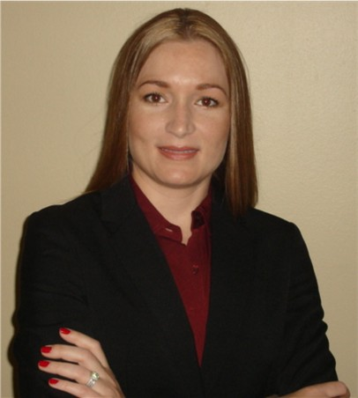
Ellen Beeson Zentner is the Senior U.S. Macro Economist for Bank of Tokyo-Mitsubishi UFJ, Ltd. (BTMU) in New York, where she is responsible for monitoring and forecasting the U.S. economy. Prior to joining BTMU in 2003, Ms. Zentner served as a senior level economist for Carole Keeton Strayhorn, Texas State Comptroller.

Ms. Zentner appears regularly on national television to provide economic commentary and her comments can be found in publications such as the New York Times, Investor’s Business Daily, and the Wall Street Journal. She has most recently received the award of Forecaster of the Month from CBS MarketWatch and is a participant in the Blue Chip Survey of professional forecasters.

Ms. Zentner holds a B.A. and Master’s degree in economics from the University of Colorado.

