Steven M. Harding
Senior Vice President and Managing Director
Independent Fiduciary Services®
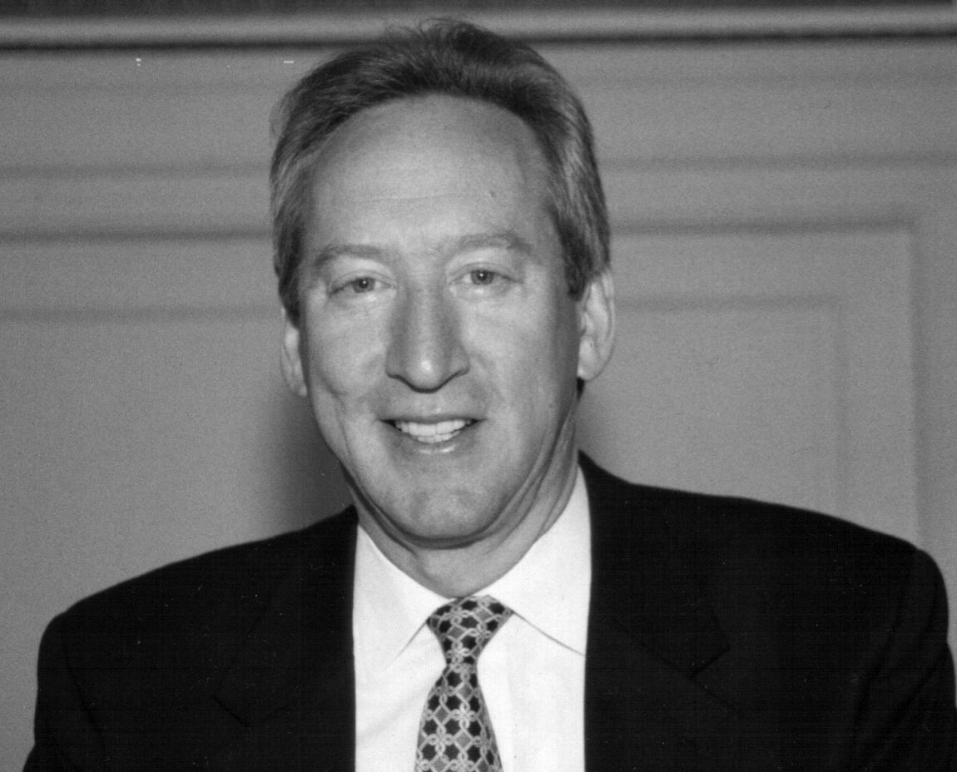
Steven M. Harding has twenty-seven years of risk management expertise in financial services, and is a nationally recognized expert on risk controls over public pension funds. Mr. Harding directs the fiduciary audit and operational review practice of Independent Fiduciary Services, Washington, DC. He joined IFS in 1999.

Prior to that, Mr. Harding was Assistant Director of Internal Audit in the Office of the New York State Comptroller where he worked from 1990 to 1999. He was responsible for financial, compliance and operational audits of the $100+ billion New York State and Local Employees’ Retirement System.

In 1991, Mr. Harding became founding President of the Association of Public Pension Fund Auditors, Inc. APPFA currently has more than 75 public pension members and has established written standards for operational risk management of investment and benefit programs.

Beginning in 1982, Mr. Harding worked for more three years in Coopers & Lybrand’s Albany, NY office. He became a Certified Public Accountant in 1984. He then worked in the securities industry from 1985 to 1988 as Internal Auditor for First Albany Corporation, a publicly held broker-dealer. He earned the Series 7 and 63 licenses and served as Chairman of the New York State Society of CPAs Stockbrokerage Committee and member of the committee for five years. From 1988 to 1990 he worked for an Albany based regional CPA firm.

Mr. Harding was an adjunct professor of accounting at the graduate School of Business of the University at Albany for ten years. Mr. Harding is also a 1981 graduate from UAlbany with a B.S. in Accounting with honors.

He is author of Auditing External Real Estate Advisors: 101 Best Practices. He served as board member of the Foundation for Fiduciary Studies from 2003 to 2006. Mr. Harding is a member of the American Institute of Certified Public Accountants and the Institute of Internal Auditors.

